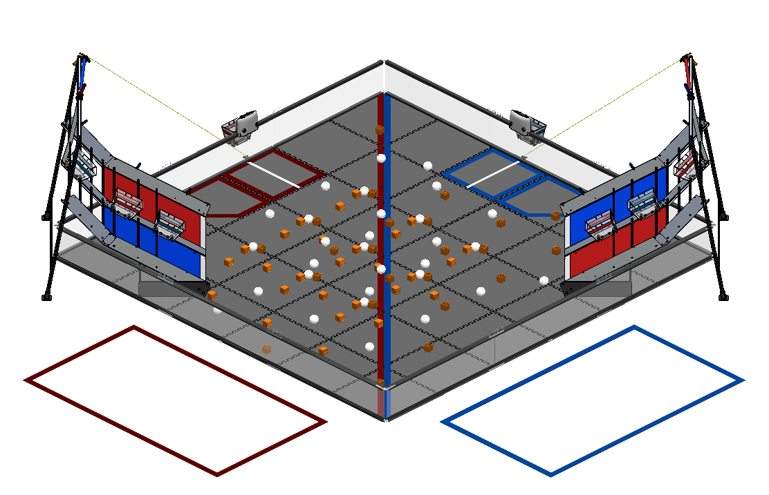

F.T.C. 2015-16

**“Res-Q”**

**PHI Alpha Hardware Log**

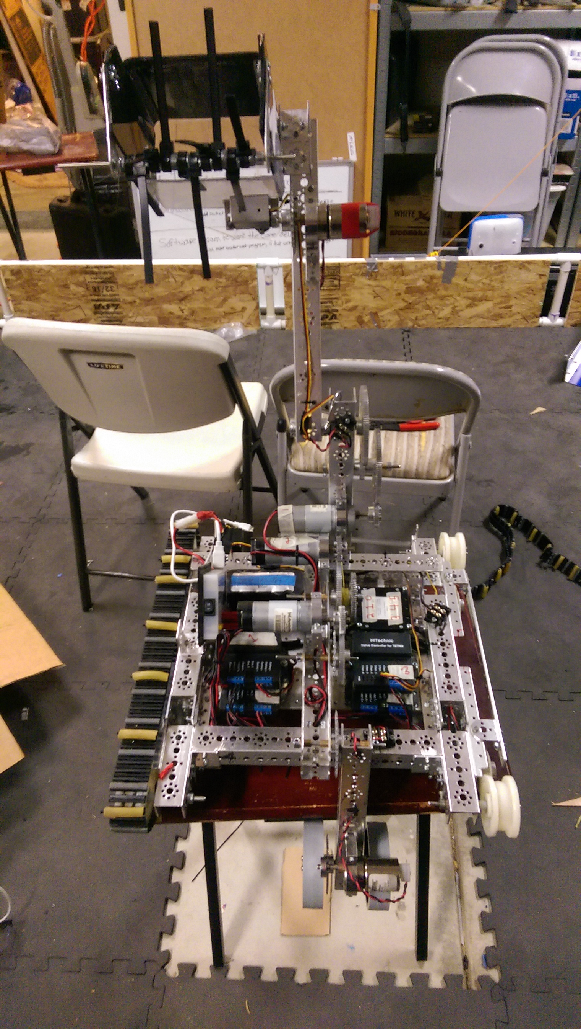“Robot - X”

Our robot, given the name of “Robot – X”, is the one of the first tread driven robots that our team has ever built. In the past, we have chosen to design a robot with a wheel drive train, but this year, we decided that tread may be a more effective system for this year's challenge rather than our traditional wheel system. Our robot is built of primarily Tetrix metal parts, but we do have some custom made pieces. Has several functions. On the from of the robot, there is a rake and bucket assembly that is used for picking up balls and blocks to score in the mountain buckets. On the rear, we designed and built a powered wheelie bar, to keep the robot stable while climbing the mountain during the match, as well as during the end game. A servo is mounted on the front left corner of the robot, which is attached to a carbon fiber rod. This is a little device we call the whip, which is used in the end game to lift the robot

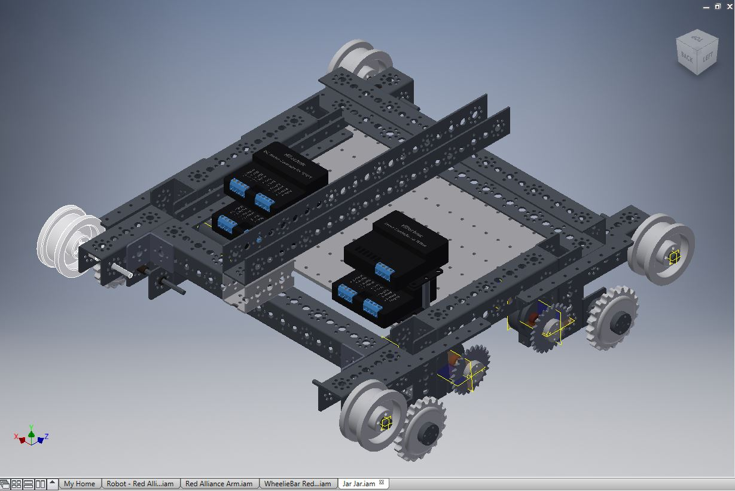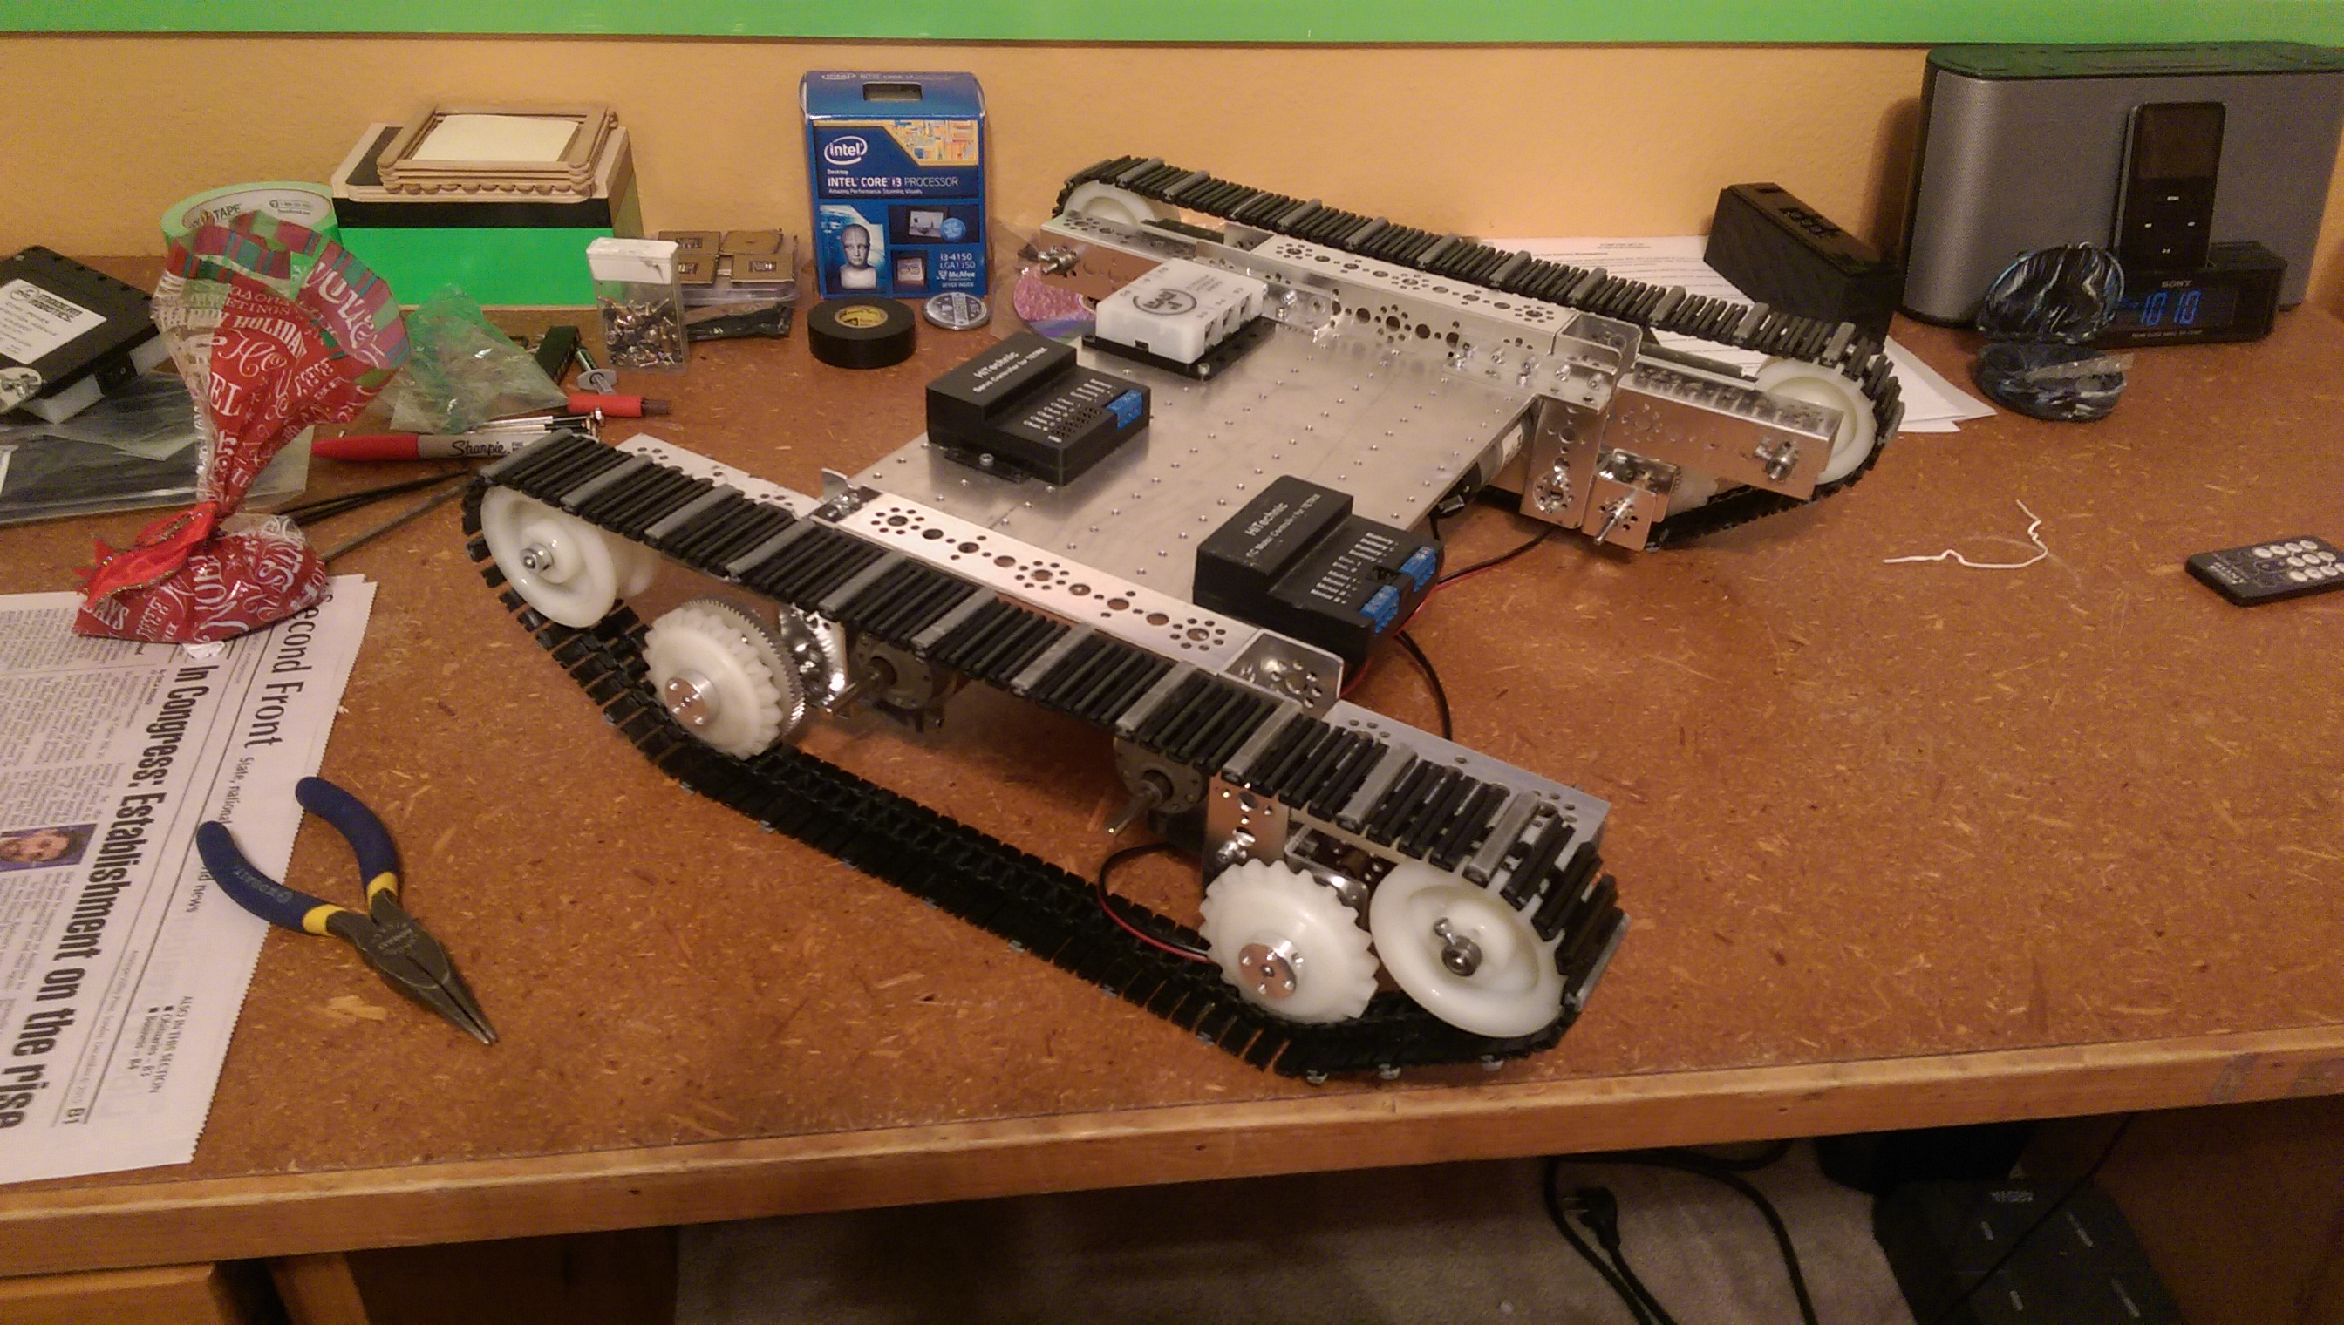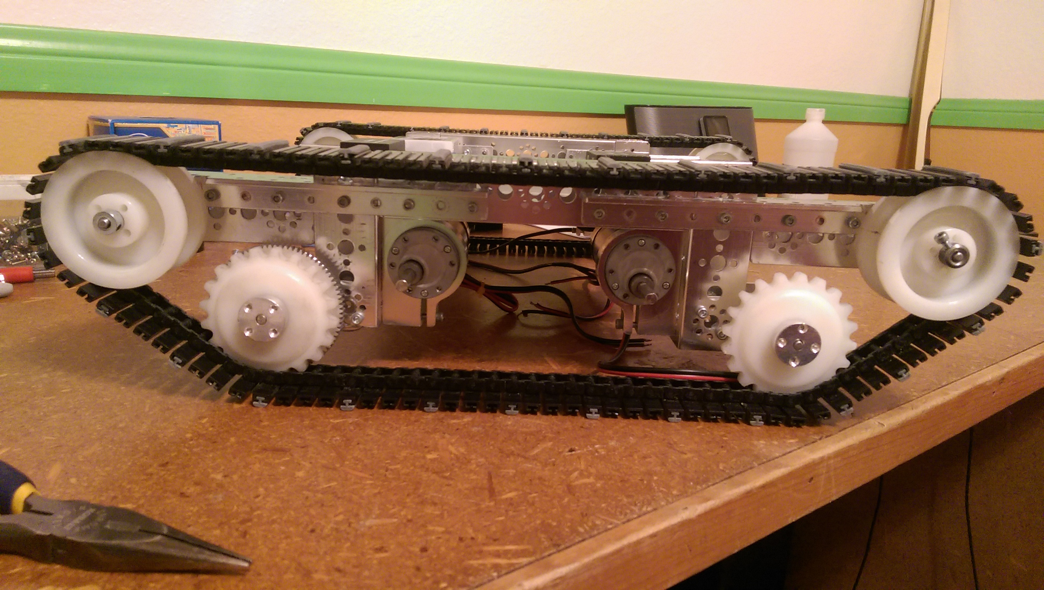Drive System And Chassis

Two Face's chassis and drive system is built around a central mounting plate. Attached on either side of the plate are an assembly of Tetrix parts that make up the tread system. The motors are mounted underneath the plate, to give a low COG and more mounting space on the surface of the robot. The front and back of the tread is built at an angle so that we can drive up and over the mountain churros.

The robot has potential for four motor drive, but we currently only have it set up for two wheel drive. The reason for this is because less motors makes the robot lighter, and with this drive system, four motors did not seem necessary.

In the past, our robots have had a problem with the drive train bowing out with extended use. This robot is built to resist that. The combination of the central plate and use of angle beams keeps the robot square and straight.

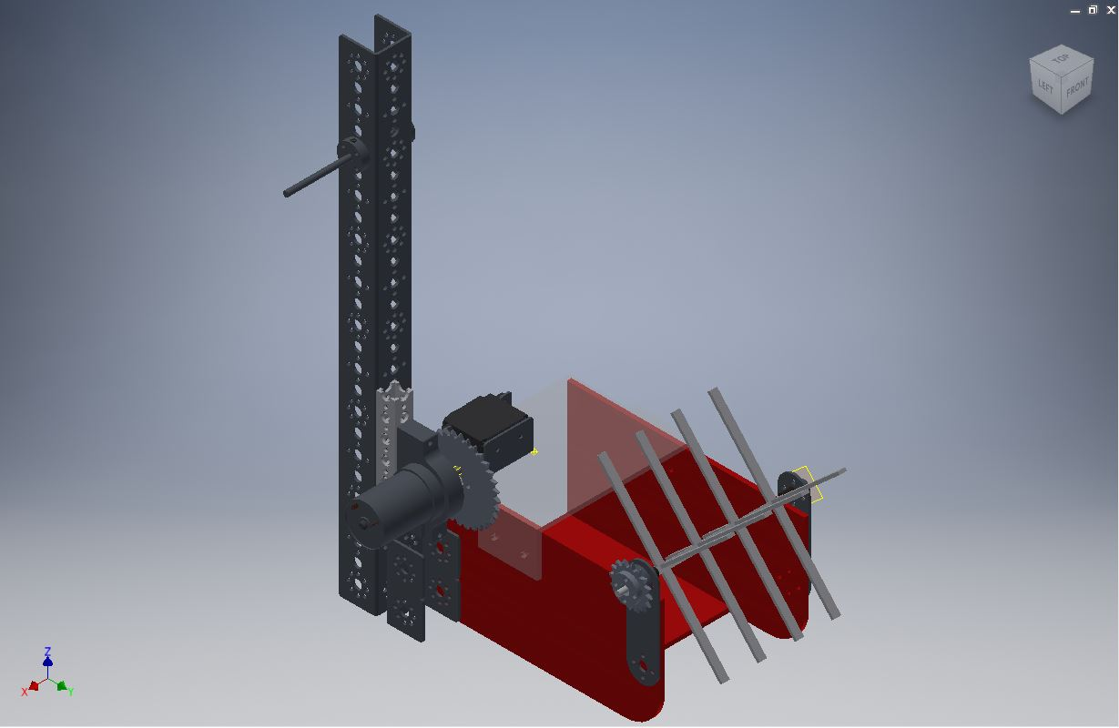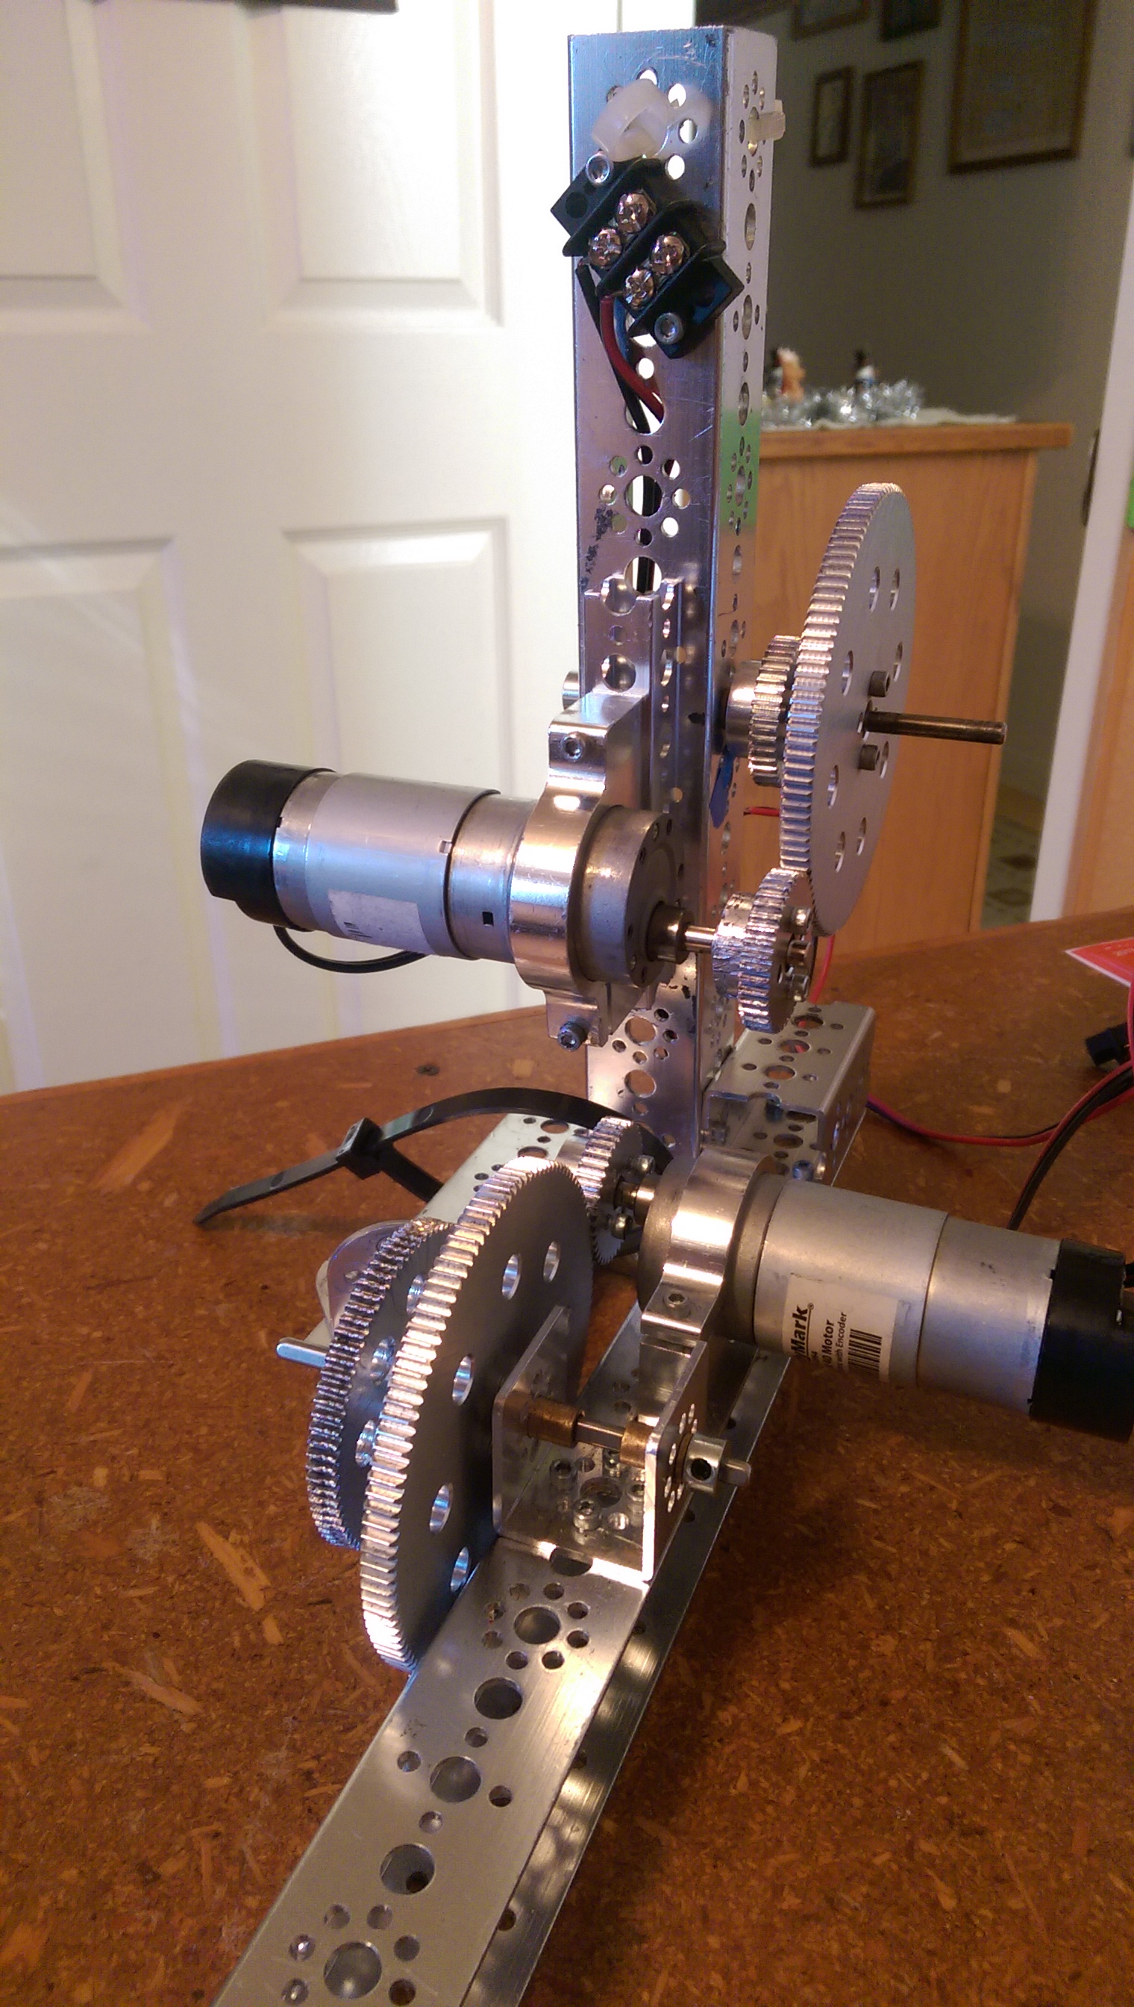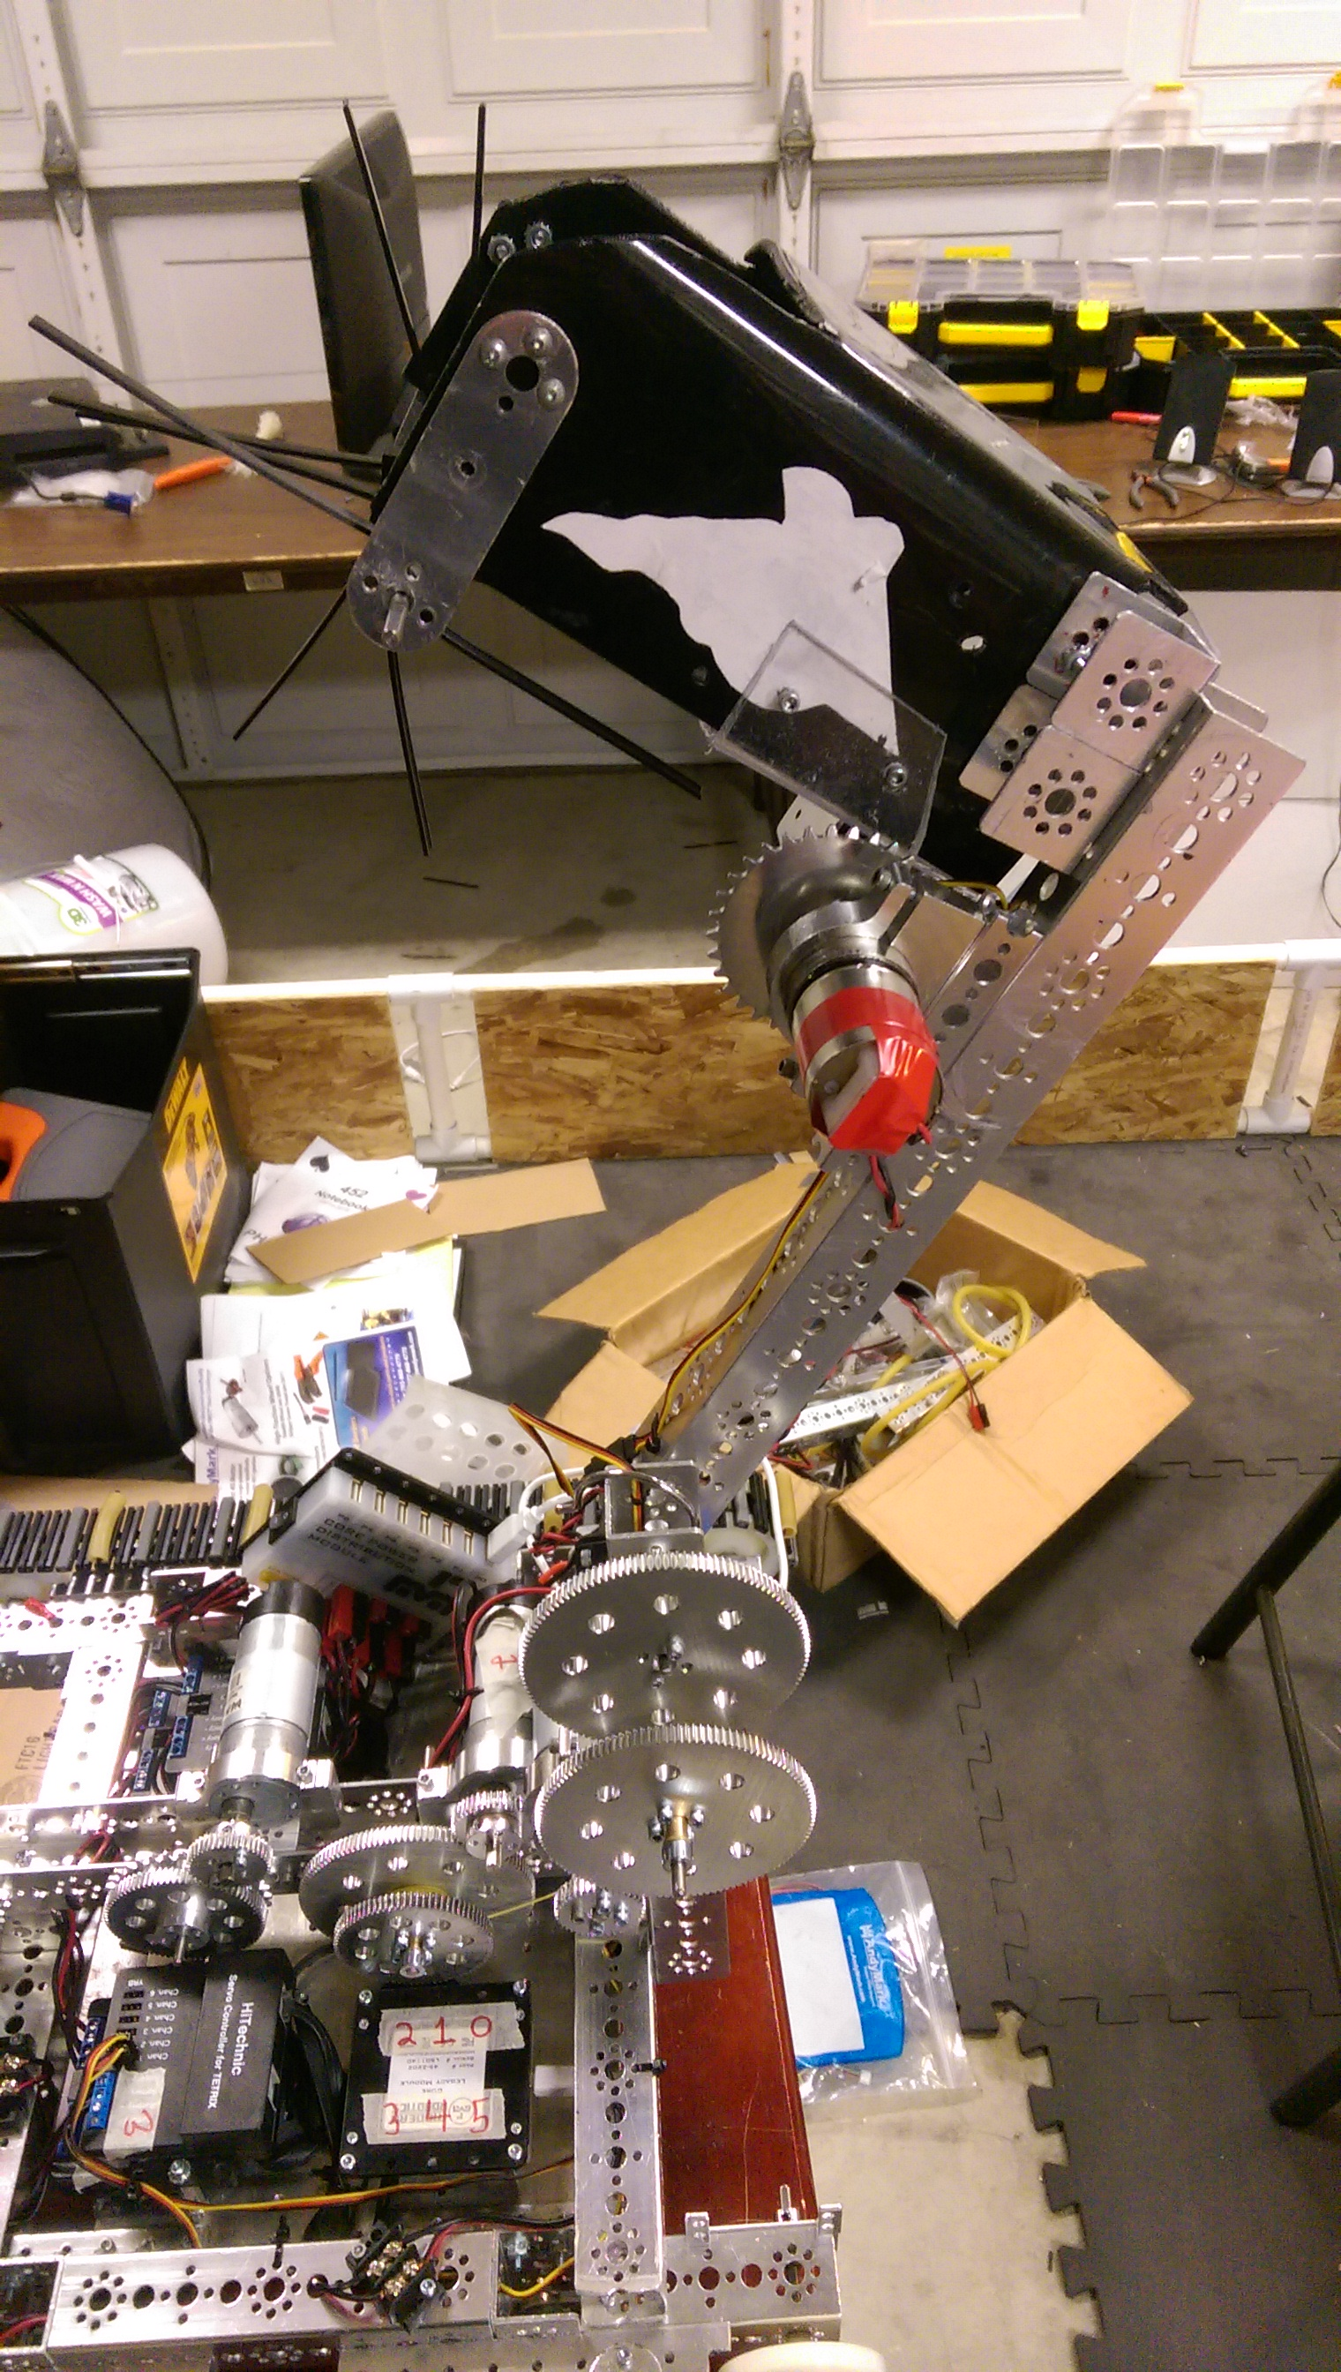**The Arm**

This arm is used during the two minute driver period to pick up and score the blocks and balls into the mountain goals. The arm has two main parts. There is the gear system for rotating the arm up and down, and on the end of the arm is the bucket.

The gear system is powered by an AndyMark motor, and has a gear ratio of ________________. We originally started out with a smaller gear ratio of ________________, but the robot arm would slowly drop while we drove, and made scoring and maneuvering around the field difficult. Our current gearing allows for precise control of the arm, and is much easier to use.

The bucket has been built to hold 4 field elements. On the front there is a powered rake that spins and sweeps elements from the field floor into the bucket. This rake is powered by a Tetrix motor connected via chain. On the rear of the bucket is a trapdoor powered by a servo. When the bucket is aligned on top of a mountain goal, the trapdoor will open and the contents fall into the goal.

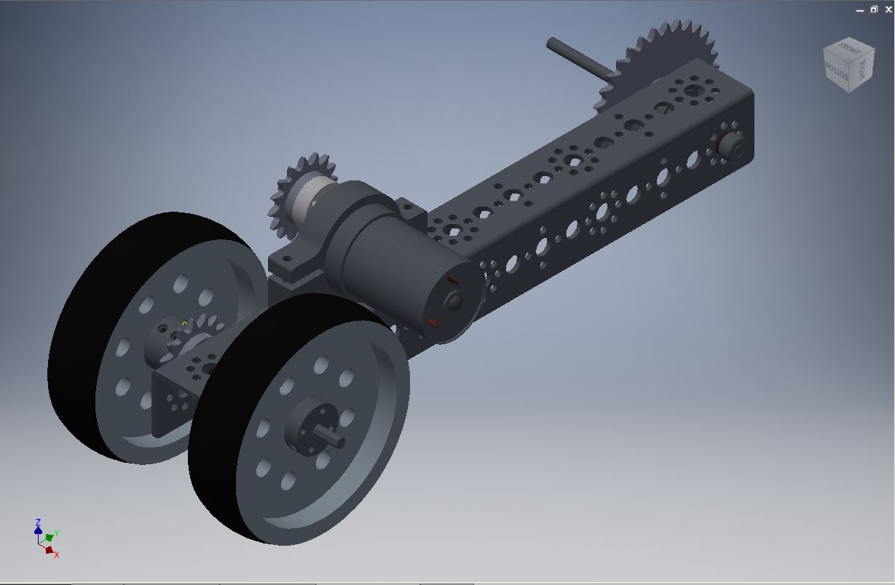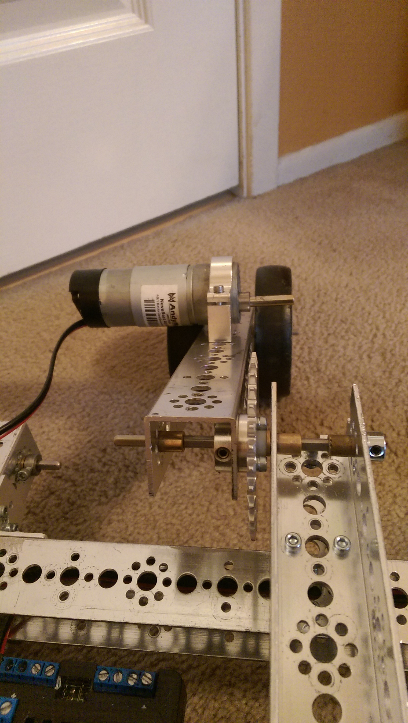

The Wheelie Bar

**The Wicked Whip of the Left (The Whip)**